# **Unit 6 – Review**

1. Recall your representations of the atoms in the Sticky Tape activity. Below is a pair of tapes before they have been pulled apart. **Explain** whether or not they would exert a force (either attractive or repulsive) on one another.

2. Below are groups of the inner cores of the atoms of the tapes after they have been pulled apart. Sketch in the mobile negative charges to show how the top tape becomes (+) and the bottom becomes (-).

3. What evidence allowed us to conclude that the top tape was (+)?

4. Below is a group of the inner cores of a piece of metal foil. Sketch in where you would expect to find the mobile negative charges if a top (+) tape were brought to the left of the foil. Explain your diagram.

5. Describe how JJ Thomson concluded that the mobile charged particle in the atom had a (–) charge.

6. A solution of salt conducts electricity; a solution of sugar does not. Explain.

7. Below left is a 2-D array that represents an ionic lattice. At right is a 2-D array that represents a molecular solid. In what ways are they similar? In what ways are they different? What is a unit cell? Can you identify one below?

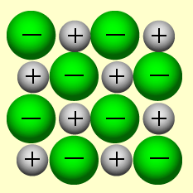

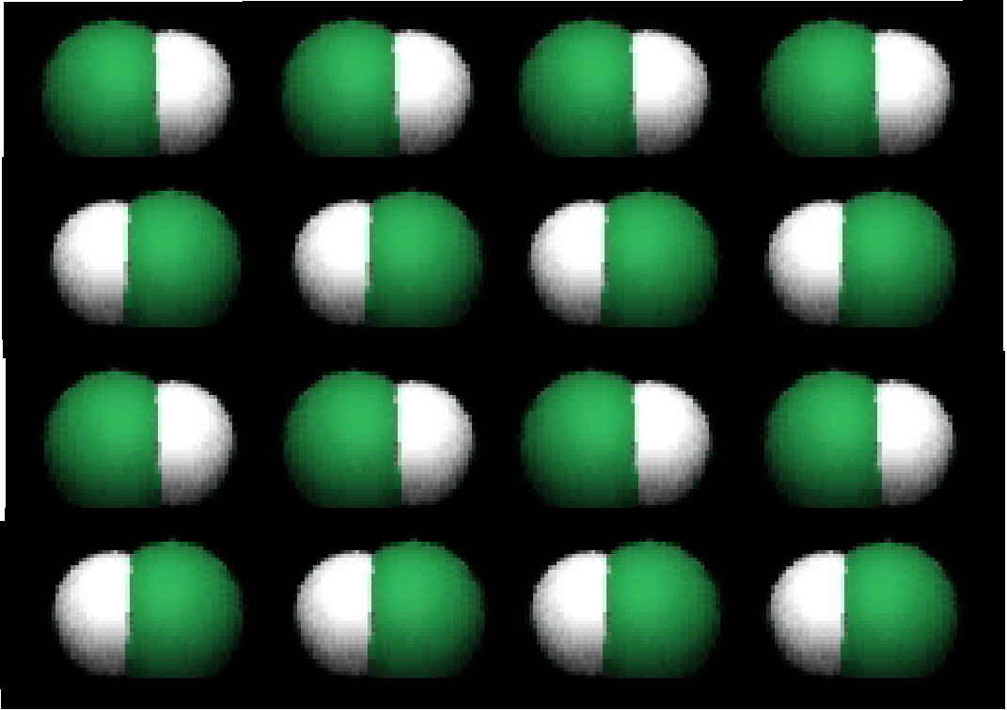

8. What evidence helped us to conclude that copper ions have a (+) charge?

9. How do you decide how many ions of each type combine to form an ionic compound?

10. Why do ionic solids have higher melting and boiling points than do most molecular solids?

11. How many ions are formed when solid Na2SO4 dissolves?

In what ways are the (+) and (–) ions different?

12. Make sure that you know which combinations of elements give rise to ionic compounds and which form molecular compounds.